**Raymon RTL plugin**

RTL plugin is a very powerful and fast text converter for generating Arabic, Hebrew, Afghan, Persian, Urdu and Kurd well-formatted right to left text which can be used in both design and run-time. If you are working with Adobe Photoshop, Flash, 3Ds Max, Maya, Unity3D and other designing software for producing right to left content you would need this tool sooner or later.

[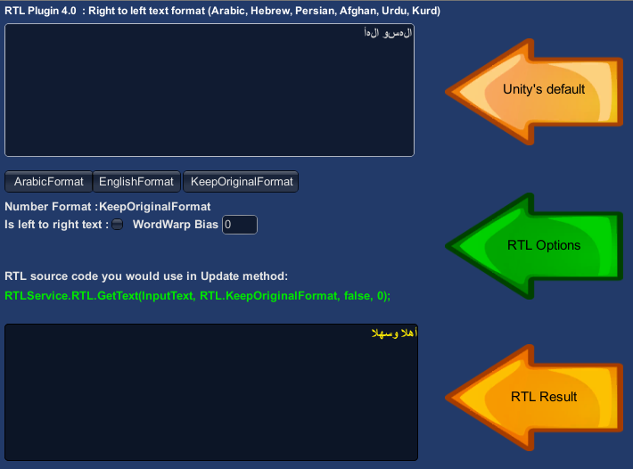](http://heygamers.com/RTL-Demo/Shot1.png)

How to use

RTL Converter is a very well structured class library (DLL) to be as fast as possible. This class contains one public static method GetText() doing the conversion. You would call this function in your update method of game or whenever you need to convert the text in your windows and web applications. This method has 4 parameters.

- input:

This parameter is the original text that you want to convert.

- numberFormat:

With this optional parameter you can define the output number format.

KeepOriginalFormat: Number format will be the same as it is in the input text.

ArabicFormat: Force the numbers appear in Arabic (Persian, Kurd, Afghan, Urdu, etc.) format.

EnglishFormat: Force the numbers appear in English (French, etc.) format.

(Default value is set to KeepOriginalFormat)

- isLtrText:

This is an optional Boolean parameter which will be need as you want to convert an English text including some right to left words. In other words, your entire sentence is in English (or French or any other normal left to right languages) but within, there are some right to left words. So in this case you can pass true with this parameter.

- wordWrapBias:

This is the fourth optional parameter. By this integer parameter you can easily adjust word wrapping simulator length in characters. The default value for this parameter is set to zero which will ignore word wrap simulator.

Examples Usage in Unity3D

string _convertedText = RTLService.RTL.GetText("السلام و علیک");

After running this code, in convertedText variable we will have well-formatted right to left Arabic text to render it in Unity game or any other applications.

GUILayout.TextField(RTLService.RTL.GetText(text),GUILayout.Height(150),GUILayout.Width(250));

This example use Unity's GUILayout to show converted right to left text.

It’s always a good idea to not use the RTL plugin or any Computational function directly in OnGUI() function. In Update method you can store the result of these kind of functions in variables, then use these them in OnGUI().

If you have any question please contact us: [[raymongame@gmail.com](mailto:raymongame@gmail.com?subject=RTL%20Support%20-%20)]

Good Luck,

RaymonGame